**Project Design Phase-II**

**Technology Stack (Architecture & Stack)**

|  |  |
| --- | --- |
| Date | 03October 2022 |
| Team ID | PNT2022TMID40555 |
| Project Name | Project – Emerging Methods are Early Forest Fire Detection |
| Maximum Marks | 4 Marks |

**Technical Architecture:**

we propose a new approach based on **the integration of Data Mining techniques into sensor nodes for forest** detection

**Example: Order processing during pandemics for offline mode**

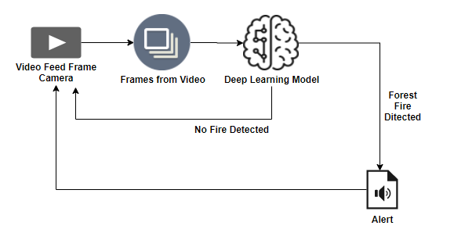

**Table-1 : Components & Technologies:**

|  |  |  |  |
| --- | --- | --- | --- |
| **S.No** | **Component** | **Description** | **Technology** |
|  | User Interface | How user interacts with application e.g. sensor based system,application based sysem. | HTML, CSS, JavaScript / Angular Js / React Js etc. |
|  | Application Logic-1 | Logic for a process in the application e.g: registreation process. | Python |
|  | Application Logic-2 | Logic for a process in the application e.g registration process successful then go to login process | Python |
|  | Application Logic-3 | Logic for a process in the application e.g: login successfully. | Ipython |
|  | Database | Data Type, Configurations etc. | MySQL, NoSQL, etc. |
|  | Cloud Database | Database Service on Cloud | IBM DB2, IBM Cloudant etc. |
|  | File Storage | File storage requirements | IBM Block Storage or Other Storage Service or Local Filesystem |
|  | External API-1 | Purpose of External API used in the application | IBM Weather API, etc. |
|  | External API-2 | Purpose of External API used in the application | Aadhar API, etc. |
|  | Machine Learning Model | Purpose of Machine Learning Model | Object Recognition Model, etc. |
|  | Infrastructure (Server / Cloud) | Application Deployment on Local System / Cloud  Local Server Configuration:  Cloud Server Configuration : | Local, Cloud Foundry, Kubernetes, etc. |

**Table-2: Application Characteristics:**

| **S.No** | **Characteristics** | **Description** | **Technology** |
| --- | --- | --- | --- |
|  | Open-Source Frameworks | open-source frameworks used | Technology of Opensource framework |
|  | Security Implementations | access controls implemented, use of firewalls,google crome , etc. | Technology used |
|  | Scalable Architecture | scalability of architecture e.g:early alarm in real time whwn the forest occure. | Technology used |
|  | Availability | availability of application (e.g. customer service and support to the mobile aoo) | Technology used |
|  | Performance | performance of the application (number of options and no.of activity performed). | Technology used |